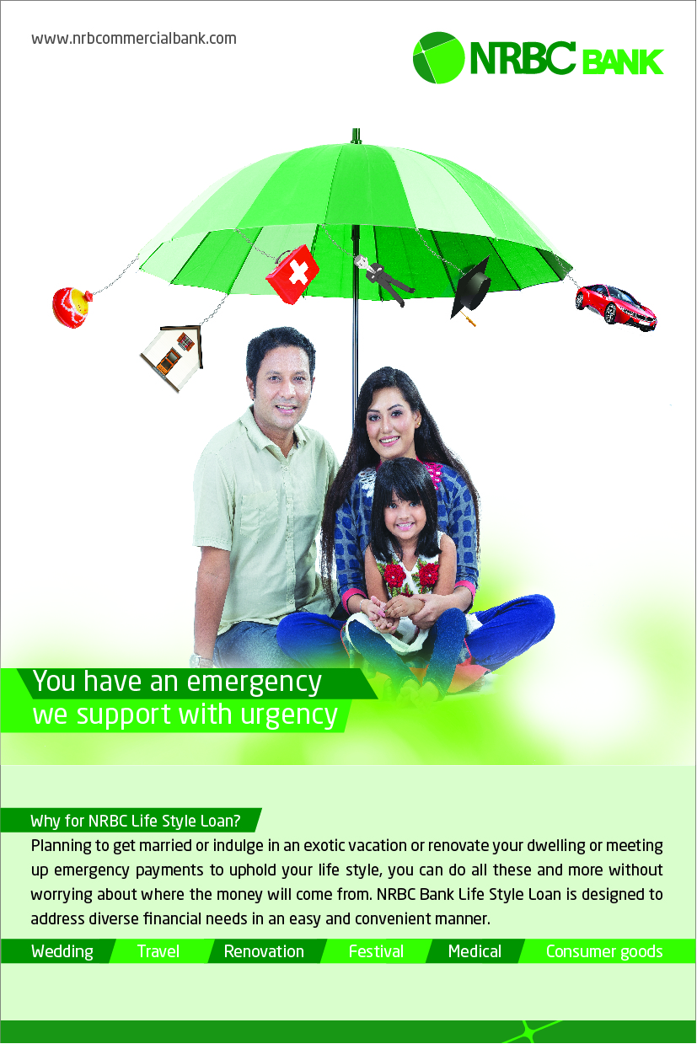
Why NRBC Life Style Loan?
If you plan to get married or indulge in an exotic vacation or renovate your dwelling or meet up emergency payments to uphold your life style, you can do all these and more without worrying about where the money will come from. NRBC Bank Life Style Loan is designed to address diverse financial needs in an easy and convenient manner.
Features of NRBC Life Style Loan
- Collateral free flexible financing solution
- Income aggregation is allowed in case of joint application with spouse.
- Top Up facility in need of additional finance
- No early settlement fee on maximum 25% of principle settlement
- Minimal documentation and hassle-free application

Loan Amount
- Minimum 50,000
- Maximum 20 Lac
Loan Tenor
- Flexible loan tenor ranging from 24 months to 60 months
Eligible person for NRBC Life Style Loan
Loan offered to diversified professionals including salaried individuals, businesspersons, practitioners and Landlords.
- Salaried: Serving in any reputed organization
- Businessperson : Businesspersons having 3 years of experience in same business
- Practitioners : Individuals engaged in private practice
- Landlords: Landlords with sufficient rental income from properties
Documentation:
- Common for all segments:
- Duly completed & signed application form
- Photocopy of valid photo id (NID/Passport)
- 1 Passport sized recent photograph
- Photocopy of Latest TIN certificate
- Copy of Utility Bill of Residence Address
- Sanction letter(s) of all other loan(s) (If any)
- Salaried Individual:
- Letter of Introduction
- Salary Certificate/Pay Slip
- Last 6 (Six) months bank statement of salary account
- Business Person:
- Valid Trade License
- Trade License of last 3 years
- Last 12 months bank statement
- Updated Form X and XII (for limited company)
- Copy of Utility Bill of Business Address
- Private Practice:
- Copy of Certificate of professional degree
- Copy of Membership Certificate with respective professional association
- Last 12 months bank statement
- Landlord:
- Rental Agreement
- Proof of property ownership
- Last 6 months bank statement

